Safe Staffing Report January 2024
The following report provides a summary staffing position across the wards for December 2023 in line with national reporting requirements.

Summary Position.
There was one reported staffing issue from Datix. This has been verified with the information intelligence team. It is likely that this due to under reporting of staffing incidents. There were 0 reported in November. Triangulation of complaints and clinical patient safety incident data sets involving medication, falls, pressure ulcers, absent and missing, seclusions, prone restraints, self–harm and assaults did not reveal any incidents of moderate harm or above during the month as a result of staffing levels.
The total number of temporary staff requests for December was 6024 compared to November at 5473. The need for temporary staff continues to be driven by vacancy, absence and the need to increase staffing numbers to meet acuity and need of patients.

All of our Mental Health and Community Wards are staffed to provide two registered staff on every shift and the shifts with less than two registered staff on duty are seen as a red flag and highlighted in table 1. For Campion Unit (Learning Disability unit) the agreed staffing levels are two registered nurses during the day and one registered nurse at night. The number of shifts reported with less than two registered nurses (RN) per shift in December was 61 from November at 51 and October at 60. On shifts with less than two registered nursing staff there were senior clinical staff on the wards (Ward Manager, Matron and for PPH there is also a Clinical Development Lead) and therapy staff based on the wards 9-5pm during the week that provided support. At PPH staff were moved across the hospital (including APOS staff) to assist wards with less than 2 registered staff in meeting their minimal staffing requirements and support is also provided by the Designated Senior Nurse on duty and a senior Band 7 nurse for night duties. The provision of these staff who are not counted within the safer care tool need to be factored in when assessing the provision of safe and appropriate care.

During December, there was no restriction to admissions activity in bays or whole wards across the Trust because of Covid despite the increase in numbers.

Temporary staffing
As part of the international nursing recruitment pilot the East and West CHS wards are to employ most of the international recruits. As of November 2023, there have been 13 nurses recruited to the community wards. The number of international nurse recruits at PPH remains at 8 and is unchanged.

 | Total number temporary staffing shifts requested | Number of temporary shifts requested to fill registered staff gap | Total temporary shifts unfilled
PPH | 4839 (4130 November) | 753 (710 November) | 226 (4.67%)
West community Wards | 918 (517 November) | 275 (258 November) | 91 (9.91%)
East Community Wards | 348 (199 November) | 64 (34 November) | 40 (11.49%)
Campion | 369 (263 November) | 96 (72 November) | 44 (11.92%)

Average Bed occupancy across the month
 | Average occupancy current reporting month (comparison to last month)
PPH Acute adult  PPH Older adult | 94.07% (94.88%)
 | 85.75% (93.6%)
West community Wards | 89.68% (93.32%)
East community wards | 83.09% (92.8%)
Campion | 83.55% (65.9%)
Occupancy 90% and below | Occupancy 90-95% | Occupancy 95% and above

Risks identified.
- Number of current registered nurse and healthcare assistant vacancies across Prospect Park Hospital.
- Number of bank and agency staff used to ensure safe staffing levels.
- Sickness and absence levels.

Main themes in relation to safe staffing:
- Recruitment of both Registered Nurses and HCAs remains challenging in line with the national picture.
- There continues to be a high level of temporary staff usage to cover vacancies, absences and high levels of observations and filling of all rota gaps with temporary staff continues not to be achieved.

Safe Staffing Declarations.
Most of the wards have some vacancy, with Prospect Park Hospital experiencing the most significant vacancy. Alongside this sickness absence levels remain high across the wards and as a result, there is continued high use of temporary staff to achieve the position of safe staffing numbers. The continual high use of temporary staffing reduced registered nursing staff on some shifts and inability to fill all temporary staffing requests means that staffing was not always optimal and patient experience may have been compromised. Additional staff including senior registered practitioners not counted in staffing numbers and therapy staff not included in the safer staffing tool work on the wards providing direct patient care which means that the wards have been assessed as safe. There have been no incidents reported as a direct result of staffing.

Safe staffing overview table
The table below displays the total budgeted workforce and vacancy data. The total monthly planned staff hours versus actual staff hours (percentage fill) along with the care hours per patient day (CHPPD) are also reported. The Care Hours per Patient Day (CHPPD) metric was developed to provide a consistent way of recording and reporting deployment of staff providing care on inpatient wards, and while it is recognised that the needs of patients using services are often quite different, the CHPPD measure provides a representation of the number of care hours available to patients. This information in the table is split by day shift/night shift and by registered nurses/unregistered care staff. Sickness absence is reported a month in arrears overall for the trust but has been taken from Health Roster for this report as data is available.
From October 2023 all ward vacancy figures are now provided by Finance. This has influenced the data reporting and shows a slight variance in staffing numbers for both qualified and non-qualified staff on all wards because of the change. Figures were previously provided by Human Resources (HR) and the figures were based on historical establishments, so the new process is a more accurate reflection of vacancies on all the inpatient wards. This is also emulated in the whole-time equivalent (WTE) numbers for all the wards in the staffing overview table. Some of the change in the available unregistered workforce at PPH is linked to the change in recruitment process whereby the Trust is employing non-registered staff via NHSP and then onboarding them after a period of time.
In addition to the data within the table below the SafeCare tool which is aligned to e-roster is now used across all wards, this enables wards to capture daily the CHPPD required for the acuity of patients (this is detailed in appendix one alongside more detailed information) and to use this for clinical decision making in terms of staff deployment.

Current nursing workforce and vacancies:

 | Registered nurses (wte) | Vacancy (wte) | Total available registered nurses (wte) | Unregistered nurses (wte) | Vacancy (wte) | Total available unregistered nurses (wte)
PPH | 92.4 | 42.95  (46.45%) | 49.45 (53.55%) | 200.69 | 60.11  (32.94%) | 134.58 (67.06%)
Campion | 10.8 | 0.8 (7.41%) | 10 (92.59%) | 22.2 | 3.08 (13.87%) | 19.12 (86.13%)
West CHS wards | 53.39 | -1.52 (-2.85%) | 54.91 (102.85%) | 72.66 | 4.6 (6.33%) | 68.06 (93.67%)
East CHS wards | 29.82 | 5.42 (18.18%) | 24.4 (81.82%) | 33.47 | 10.89 (32.54%) | 22.58 (67.46%)
Total CHS wards | 83.21 | 3.9 (4.69%) | 79.31 (95.31%) | 106.13 | 15.49 (14.60%) | 90.64 (85.40%)
Total all wards | 186.41 | 47.65  (25.56%) | 138.76 (74.44%) | 329.02 | 84.68  (25.74%) | 244.34 (74.26%)

No identified impact on quality and safety of care provided as a result of staffing issues | Although there appears to be no direct correlation between staffing and any specific incidents that occurred during the month, the high number of temporary staff required throughout the month provides a challenge with delivering continuity of care and may compromise patient experience | There appears to be a correlation between staffing and specific incidents, safety was compromised

December 2023 | Budgeted workforce (wte) | Vacancy  (wte) | % DAY FILL RATE |  |  |  | % NIGHT FILL RATE |  |  |  | Bed Occupancy % | CARE HOURS PER PATIENT DAY |  |  |  |  |  | No. of shifts with less than 2 RN |  | No. of incidents reported linked to staffing | No incidents where harm caused as a result of reduced staffing
 |  |  | RN | HCA | Q NA | UnQ  NA | RN | HCA | Q  NA | UnQ  NA |  | Month cumulative patient count | RN | HCA | Q RA | UnQ RA | Total | Day | Night |  |  | RAG rating
Bluebell | 41.87 | 15.8 | 92.74 | 133.23 | 0.00 | 0.00 | 95 | 166.67 | 0.00 | 0.00 | 94.5 | 594 | 3.9 | 6.04 | 0.0 | 0.0 | 9.94 | 9 | 5 | 0 | 0
Daisy | 41.87 | 15.65 | 107.26 | 147.42 | 0.00 | 0.00 | 96.77 | 177.49 | 0.00 | 0.00 | 95.5 | 580 | 4.5 | 8.32 | 0.0 | 0.0 | 12.82 | 0 | 2 | 0 | 0
Rose | 41.87 | 18.87 | 100.81 | 178.69 | 0.00 | 0.00 | 98.39 | 220.97 | 0.00 | 0.00 | 92.0 | 585 | 5.2 | 9.18 | 0.0 | 0.0 | 14.38 | 1 | 1 | 0 | 0
Snowdrop | 41.87 | 22.79 | 111.29 | 152.10 | 0.00 | 0.00 | 100.0 | 175.0 | 0.00 | 0.00 | 94.3 | 568 | 4.44 | 8.89 | 0.0 | 0.0 | 13.33 | 4 | 0 | 0 | 0
Orchid | 41.87 | 9.39 | 88.39 | 149.68 | 0.00 | 0.00 | 92.93 | 222.64 | 0.00 | 0.00 | 87.65 | 437 | 5.71 | 13.16 | 0.0 | 0.0 | 18.87 | 16 | 4 | 0 | 0
Rowan | 41.87 | 7.35 | 100.81 | 226.77 | 0.00 | 0.00 | 96.77 | 250.0 | 0.00 | 0.00 | 83.85 | 461 | 6.43 | 24.08 | 0.0 | 0.0 | 30.51 | 3 | 2 | 0 | 0
Sorrel | 41.87 | 19.93 | 96.77 | 130.0 | 0.00 | 0.00 | 95.16 | 150.81 | 0.00 | 0.00 | 91.18 | 334 | 4.28 | 15.38 | 0.0 | 0.0 | 19.66 | 6 | 3 | 0 | 0
Campion | 33.0 | 3.88 | 169.35 | 213.71 | 178.72 | 0.00 | 200.0 | 129.84 | 0.00 | 0.00 | 83.55 | 212 | 3.34 | 34.13 | 0.31 | 0.00 | 38.10 | 0 | 0 | 0 | 0
Donnington | 49.97 | 4.45 | 95.70 | 119.71 | 103.3 | 0.00 | 98.39 | 120.97 | 0.00 | 0.00 | 85.16 | 792 | 3.04 | 4.47 | 0.4 | 0.00 | 7.91 | 0 | 1 | 0 | 0
Highclere |  |  | 107.26 | 111.67 | 115.25 | 0.00 | 98.39 | 104.84 | 0.00 | 0.00 | 94.2 | 409 | 2.53 | 7.43 | 0.6 | 0.00 | 10.56 | 1 | 1 | 0 | 0
Oakwood | 32.13 | 0.44 | 105.91 | 103.54 | 0.00 | 0.00 | 100.0 | 148.39 | 0.00 | 0.00 | 93.25 | 706 | 3.05 | 4.64 | 0.0 | 0.0 | 7.69 | 0 | 0 | 0 | 0
Ascot | 43.95 | -1.81 | 100.0 | 84.95 | 0.00 | 0.00 | 100.0 | 116.13 | 0.00 | 0.00 | 82.83 | 422 | 1.98 | 5.58 | 0.0 | 0.0 | 7.56 | 1 | 0 | 0 | 0
Windsor |  |  | 93.23 | 111.06 | 0.00 | 0.00 | 122.58 | 103.81 | 0.00 | 0.00 | 82.75 | 734 | 2.31 | 4.02 | 0.0 | 0.0 | 6.33 | 0 | 0 | 0 | 0
Henry Tudor | 32.80 | 10.21 | 120.05 | 99.11 | 0.00 | 0.00 | 160.47 | 163.92 | 0.00 | 0.00 | 84 | 584 | 2.34 | 6.42 | 0.0 | 0.0 | 8.76 | 0 | 0 | 1 | 0
Jubilee | 30.6 | 6.10 | 84.46 | 89.06 | 0.00 | 0.00 | 96.77 | 145.16 | 0.00 | 0.00 | 82.18 | 568 | 2.82 | 4.51 | 0.0 | 0.0 | 7.33 | 0 | 1 | 0 | 0

Appendix 1

Prospect Park
Across the acute wards a total of 141 (5.76%) shifts were unfilled by bank or agency, for Sorrel a total of 18 (3.82%) shifts were unfilled by bank or agency and across the older adult wards a total of 77 (5.22%) shifts were unfilled by bank or agency. At PPH all the wards have dedicated therapy resources which provide care to patients. In addition, there are matrons, clinical development leads and activity coordinators who support the wards and are not included in the rota.
The percentage of RN shifts covered on the acute wards by bank staff on each ward varied from 6.26% to 14.70% and the non-qualified shifts covered by bank staff varied from 42.82% to 60.04% of all shifts during the month. Sorrel Ward had 11.19% of RN shifts and 50.90% of non-qualified shifts covered by bank staff. There were no shifts covered by agency. Rowan Ward had 6.59% of RN shifts and 59.20% of non-qualified shifts covered by bank staff. Orchid Ward had 12.26% of RN shifts and 46.23% of non-qualified shifts covered by bank staff. There were 0.95% 0f RN shifts covered by agency on the older adult wards.
Sickness absence has been very variable across the wards for November. Orchid Ward had significant sickness at 14.81%. Bluebell ward was 13.67%, Sorrel ward was 8.59%, Snowdrop ward was 9.24%, Rowan ward 10.2%, Rose ward 3.13%, and Daisy ward 3.52%.
Available data demonstrated that wards were safely staffed during December with available staffing matching patient need. Further support is being provided to the mental health wards to support completion of the daily care hours tool.

West Community Health Service Wards.

Across all the wards the safer care tool is indicating that the staffing was suboptimal for the acuity of patients, however, there are staff not counted within this including ward managers and therapy staff who were on the ward to provide care and support to the patients. Further work is being undertaken around the West ward’s establishment and dependency/acuity recording.
On Oakwood Unit 2.58% of RN staff on shift were bank staff (1.79% in November) and 13.62% of non-qualified staff (13.99% in November) were bank staff. There were no shifts filled by agency. On the West Berkshire Community Hospital wards 9.05% of rostered RN staff were bank staff (8.98% in November) and 20.69% of non-qualified shifts (17.46% in November) were covered by bank staff. There were no qualified shifts covered by agency staff (0.94% qualified shifts in November) and 11.10% of non-qualified shifts covered agency staff (10.16% in November). On Wokingham wards 12.79% of qualified nursing shifts (12.60% in November) and 13.45% of unqualified shifts (9.87% in November) were filled by bank staff. There were no shifts covered by agency staff.
Sickness data taken from Health Roster for December showed that average sickness absence on Oakwood was 3.08%, for WBCH this was 6.6% and for Wokingham unit this was 5.54%.

Oakwood Unit:  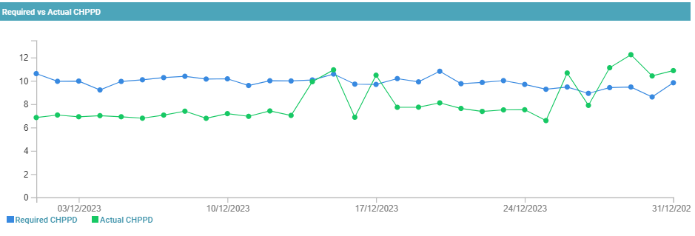 | West Berkshire Community Hospital:  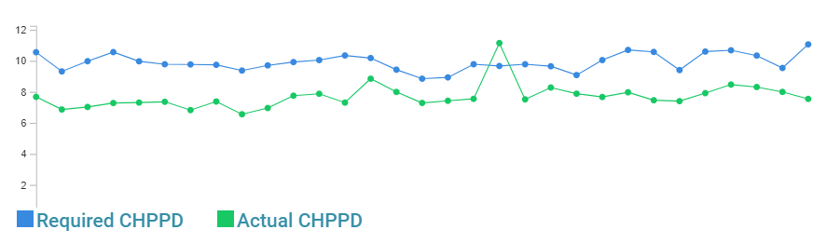
Wokingham Wards:
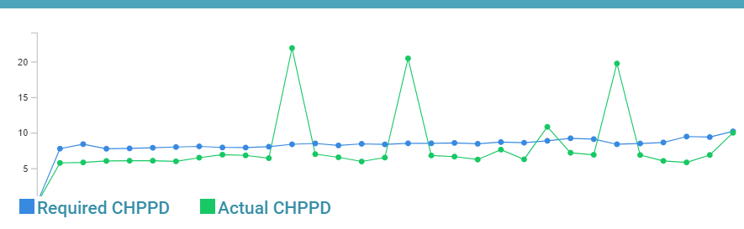

East Community Health Service Wards.
The East wards staffing to patient ratios appear to be sufficient for the acuity of patients on the ward. In addition, like the west community wards, there are therapists and therapy assistants working on the wards who support the nursing staff but are not captured in the Safecare figures. Henry Tudor had 10.04% of RN shifts (3.98% in November) and 25.91% of non-qualified shifts (23.51% in November) covered by bank staff and on Jubilee ward 2.95% of RN shifts (4.89% in November) and 25.56% of nonqualified shifts (18.06% in November) were covered by bank staff. There were no qualified shifts covered by agency on either Henry Tudor ward or Jubilee ward in December.
Sickness in December on Henry Tudor ward was 2.62% and for Jubilee ward it was 7.58%.

Henry Tudor Ward:  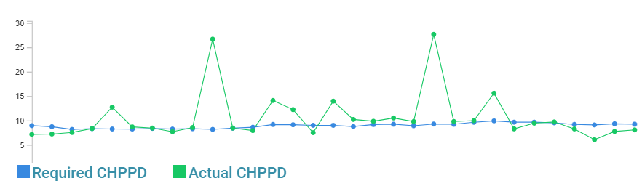 | Jubilee Ward:  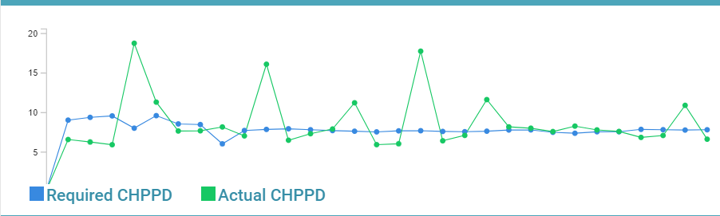

Campion Unit.
There were 0 shifts with less than two registered nurses. The number of temporary staffing shifts requested for Campion unit was 369; 96 of these were for registered nurses (26.01%). A total of 41 (11.11%) of all temporary staff requests were unfilled. There were 4 unfilled requests for a registered nurses.

Community Nursing.
A National tool devised by Keith Hurst has been launched by NHSE to examine caseload dependency scores. There is further work being undertaken at NHSE to fine tune some of the tool figures before all the results can be used. It is envisaged that this will enable greater understanding of the staffing requirements needed to meet demand and patient acuity. The pilot/test of the CNSST tool with two localities was completed in June, the results collated and included in the six-monthly board report. The CNSST has been rolled out to the remaining localities and the data collection was undertaken in the last week November. Results are currently being collated Community nursing is currently working on aligning heat maps across the trust in order that reporting can be compared across each locality.

Debbie Fulton
Director of Nursing and Therapies 07/01/2024.

